Top 10 ASP.NET Web API Interview Questions

By [IMRAN ABDUL GHANI](http://www.webdevelopmenthelp.net/author/imranghani) | May 5, 2014

[0 Comment](http://www.webdevelopmenthelp.net/2014/05/asp-net-web-api-interview-questions.html#disqus_thread)

**[](http://www.facebook.com/sharer.php?u=http://www.webdevelopmenthelp.net/2014/05/asp-net-web-api-interview-questions.html)[](https://plus.google.com/share?url=http://www.webdevelopmenthelp.net/2014/05/asp-net-web-api-interview-questions.html)[](http://twitter.com/share?url=http://www.webdevelopmenthelp.net/2014/05/asp-net-web-api-interview-questions.html&text=Top+10+ASP.NET+Web+API+Interview+Questions+)[](http://www.linkedin.com/shareArticle?mini=true&url=http://www.webdevelopmenthelp.net/2014/05/asp-net-web-api-interview-questions.html)[](http://www.digg.com/submit?url=http://www.webdevelopmenthelp.net/2014/05/asp-net-web-api-interview-questions.html)[](javascript:void((function()%7Bvar%20e=document.createElement('script');e.setAttribute('type','text/javascript');e.setAttribute('charset','UTF-8');e.setAttribute('src','//assets.pinterest.com/js/pinmarklet.js?r='+Math.random()*99999999);document.body.appendChild(e)%7D)());)**

In this **ASP.NET Interview Questions Series,** so far we have covered questions related to the core of ASP.NET technology. In this part-6 of **ASP.NET Web API Tutorial** series, we will cover top 10 ASP.NET Web API interview questions related to **ASP.NET Web API** framework. What we have covered so far can be summarized as follows:

* [*Part 1 – Interview Questions on State Management and ASP.NET Controls.*](http://www.webdevelopmenthelp.net/2014/03/asp-net-interview-questions-for-beginners-and-professionals-part-1.html)
* [*Part 2 – ASP.NET Interview Questions on Globalization and Localization, Culture etc.*](http://www.webdevelopmenthelp.net/2014/04/asp-net-interview-questions-for-beginners-and-professionals-part-2.html)
* [*Part 3 – Interview Questions on Cache Management & Security in ASP.NET.*](http://www.webdevelopmenthelp.net/2014/04/asp-net-interview-questions-for-beginners-and-professionals-part-3.html)
* [*Part 4 – ASP.NET Interview Questions on Security in Detail.*](http://www.webdevelopmenthelp.net/2014/04/asp-net-interview-questions-for-beginners-and-professionals-part-4.html)
* [*Part 5 – Top 10 ASP.NET AJAX Interview Questions*](http://www.webdevelopmenthelp.net/2014/04/top-10-asp-net-ajax-interview-questions.html)

*You can follow here to create your first*[***Single Page Application using AngualarJS and Web API***](http://www.webdevelopmenthelp.net/2015/12/spa-application-using-angularjs-webapi-all-crud-operations.html)*, covering all CRUD (Create/Retrieve/Update/Delete) Operations. Also, you can find the list of more****Advanced AngularJS Interview Questions***[*here*](http://www.webdevelopmenthelp.net/2016/10/angularjs-interview-questions.html)*.*

[**Before we start Web API Tutorial, test your skill by answering simple question?**](http://www.webdevelopmenthelp.net/2014/05/asp-net-web-api-interview-questions.html#acc-2)

You are working with WebDevTutorial as a Developer and designing an ASP.NET Web API application. You need to select an HTTP verb to allow blog administrators to moderate comments posted on Web Development Tutorial blog. Which HTTP verb should you use?

* A. GET
* B. POST
* C. DELETE
* D. PUT

*For a complete online test and Practice Exams on Web Technologies,*[*Click Here*](http://www.webdevelopmenthelp.net/free-online-test)*.*

**Correct Answer: D**

So, let’s dive deeper to understand ASP.NET Web API technology concepts through Interview Questions.

*For a comprehensive list of****ASP.NET MVC Interview Questions****,*[*follow here*](http://www.webdevelopmenthelp.net/2013/09/top-asp-net-mvc-interview-questions.html)*.*

**ASP.NET Web API Interview Questions List**

1. [What is ASP.NET Web API?](http://www.webdevelopmenthelp.net/2014/05/asp-net-web-api-interview-questions.html#Q1)
2. [What are the advantages of using ASP.NET Web API?](http://www.webdevelopmenthelp.net/2014/05/asp-net-web-api-interview-questions.html#Q2)
3. [What new features are introduced in ASP.NET Web API 2.0?](http://www.webdevelopmenthelp.net/2014/05/asp-net-web-api-interview-questions.html#Q3)
4. [WCF Vs ASP.NET Web API?](http://www.webdevelopmenthelp.net/2014/05/asp-net-web-api-interview-questions.html#Q4)
5. [WCF REST Vs ASP.NET Web API?](http://www.webdevelopmenthelp.net/2014/05/asp-net-web-api-interview-questions.html#Q5)
6. [Is it true that ASP.NET Web API has replaced WCF?](http://www.webdevelopmenthelp.net/2014/05/asp-net-web-api-interview-questions.html#Q6)
7. [MVC Vs ASP.NET Web API?](http://www.webdevelopmenthelp.net/2014/05/asp-net-web-api-interview-questions.html#Q7)
8. [How to return View from ASP.NET Web API method?](http://www.webdevelopmenthelp.net/2014/05/asp-net-web-api-interview-questions.html#Q8)
9. [How to restrict access to Web API method to specific HTTP Verb?](http://www.webdevelopmenthelp.net/2014/05/asp-net-web-api-interview-questions.html#Q9)
10. [Can we use Web API with ASP.NET Web Form?](http://www.webdevelopmenthelp.net/2014/05/asp-net-web-api-interview-questions.html#Q10)

**More Web API Interview Questions**

* [How we can provide an alias name for ASP.NET Web API action?](http://www.webdevelopmenthelp.net/2014/05/asp-net-web-api-interview-questions.html#Q11)
* [What are Exception Filters? What are different ways to register exception filters?](http://www.webdevelopmenthelp.net/2014/05/asp-net-web-api-interview-questions.html#Q12)

**What is ASP.NET Web API?**

ASP.NET Web API is a framework that simplifies building HTTP services for broader range of clients (including browsers as well as mobile devices) on top of .NET Framework. Using ASP.NET Web API we can create non-SOAP based services like plain XML or JSON strings etc. with many other advantages including:

* Create resource-oriented services using the full features of HTTP.
* Exposing services to a variety of clients easily like browsers or mobile devices etc.

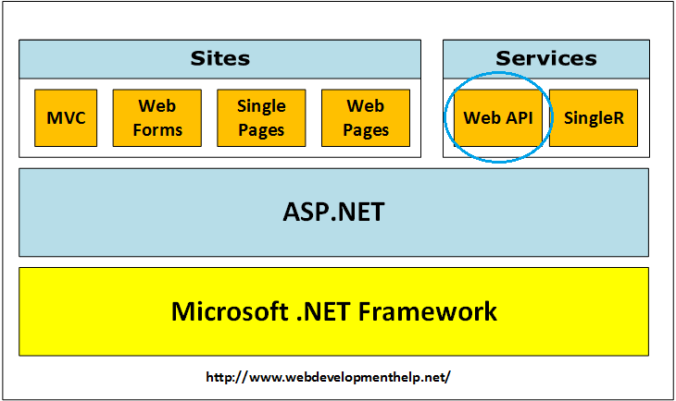[Back to top](http://www.webdevelopmenthelp.net/2014/05/asp-net-web-api-interview-questions.html#top)

**What are the advantages of using ASP.NET Web API?**

Using ASP.NET Web API has a number of advantages, but core of the advantages are:

* It works the HTTP way using standard HTTP verbs like GET, POST, PUT, DELETE etc for all CRUD operations.
* Complete support for routing.
* Response generated in JSON or XML format using MediaTypeFormatter.
* It has the ability to be hosted in IIS as well as self-host outside of IIS.
* Supports Model binding and Validation.
* Support for OData.
* and more….

For implementation on performing all CRUD operations using ASP.NET Web API, [click here](http://www.webdevelopmenthelp.net/2013/12/performing-crud-operations-using-asp-net-web-api-part-1.html).[](http://www.webdevelopmenthelp.net/exams-70-486)

[Back to top](http://www.webdevelopmenthelp.net/2014/05/asp-net-web-api-interview-questions.html#top)

**What new features are introduced in ASP.NET Web API 2.0?**

More new features introduced in ASP.NET Web API framework v2.0 are as follows:

* Attribute Routing
* External Authentication
* CORS (Cross-Origin Resource Sharing)
* OWIN (Open Web Interface for .NET) Self Hosting
* IHttpActionResult
* Web API OData

You can follow a good Web API new feature details on [Top 5 New Features in ASP.NET Web API 2](http://www.webdevelopmenthelp.net/2013/10/top-5-new-features-in-asp-net-web-api-2.html) here.

[Back to top](http://www.webdevelopmenthelp.net/2014/05/asp-net-web-api-interview-questions.html#top)

**WCF Vs ASP.NET Web API?**

Actually, **Windows Communication Foundation** is designed to exchange standard SOAP-based messages using variety of transport protocols like HTTP, TCP, NamedPipes or MSMQ etc. On the other hand, **ASP.NET API** is a framework for building non-SOAP based services over HTTP only.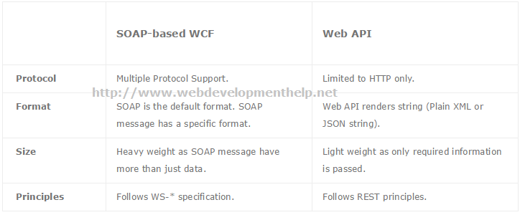[Back to top](http://www.webdevelopmenthelp.net/2014/05/asp-net-web-api-interview-questions.html#top)

**WCF RESTful Service Vs ASP.NET Web API?**

Although both WCF REST and ASP.NET Web API follows the REST architecture but these have follow differences:

**WCF REST**

* Microsoft introduced “WebHttpBinding” to be used for creating WCF RESTful Services.
* HTTP Methods are mapped to attributes, for example, “WebGet” for GET method and “WebInvoke” for POST.

**ASP.NET Web API**

* As compared with WCF REST, Web API supports full features of HTTP.
* Its possible to host Web API in IIS as well as in an application.

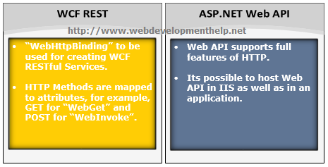[Back to top](http://www.webdevelopmenthelp.net/2014/05/asp-net-web-api-interview-questions.html#top)

**Is it true that ASP.NET Web API has replaced WCF?**

It’s a misconception that ASP.NET Web API has replaced WCF. It’s another way of building non-SOAP based services, for example, plain XML or JSON string etc.

Yes, it has some added advantages like utilizing full features of HTTP and reaching more clients such as mobile devices etc.

But WCF is still a good choice for following scenarios:

* If we intended to use transport other than HTTP e.g. TCP, UDP or Named Pipes.
* Messag Queuing scenario using MSMQ.
* One-way communication or Duplex communication

A good understanding for WCF(Windows Communication Foundation), please follow [WCF Tutorial](http://www.topwcftutorials.net/).

[Back to top](http://www.webdevelopmenthelp.net/2014/05/asp-net-web-api-interview-questions.html#top)

**MVC Vs ASP.NET Web API?**

As in previous ASP.NET Web API Interview Questions, we discussed that purpose of Web API framework is to generate HTTP services that reaches more clients by generating data in raw format, for example, plain XML or JSON string. So, ASP.NET Web API creates simple HTTP services that renders raw data. On the other hand, ASP.NET MVC framework is used to develop web applications that generates Views as well as data. ASP.NET MVC facilitates in rendering HTML easy.

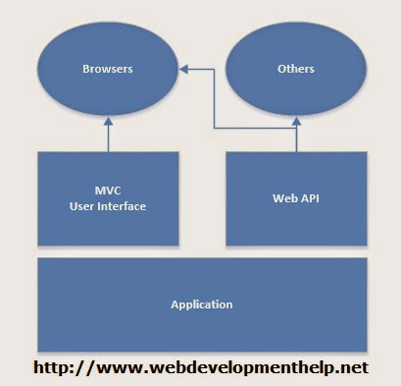

For **ASP.NET MVC Interview Questions**, [follow the link](http://www.webdevelopmenthelp.net/2013/09/top-10-asp-net-mvc-interview-questions.html).  
[Back to top](http://www.webdevelopmenthelp.net/2014/05/asp-net-web-api-interview-questions.html#top)

[**Answer this simple Question to test your skill?**](http://www.webdevelopmenthelp.net/2014/05/asp-net-web-api-interview-questions.html#acc-3)

Please look into following piece of code:

[ActionName(“GetById”)]

public ActionResult GetEmployeeById()  
{  
//Code logic here.

return View();  
}  
What’s true about the above code.

* A. “GetEmployeeById” action method with be identified and called by name “GetEmployeeById”.
* B. “GetEmployeeById” action method with be identified and called by name “GetById”.
* C. Above code will generate an error because of wrong return type.
* D. Action method can’t be called because of duplicate action method names.

*For a complete online test and Practice Exams on Web Technologies,*[*Click Here*](http://www.webdevelopmenthelp.net/free-online-test)*.*

**Correct Answer: B**

**How to return View from ASP.NET Web API method?**

(A tricky Interview Question) No, we can’t return view from ASP.NET Web API Method. As we discussed in earlier interview question about difference between ASP.NET MVC and Web API that ASP.NET Web API creates HTTP services that renders raw data. Although, it’s quite possible in ASP.NET MVC application.  
[Back to top](http://www.webdevelopmenthelp.net/2014/05/asp-net-web-api-interview-questions.html#top)

**How to restrict access to Web API method to specific HTTP Verb?**

**Attribute programming** plays it’s role here. We can easily restrict access to an ASP.NET Web API method to be called using a specific HTTP method. For example, we may required in a scenario to restrict access to a Web API method through HTTP POST only as follows:

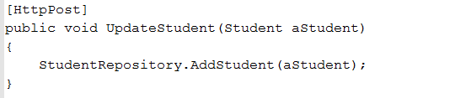

[Back to top](http://www.webdevelopmenthelp.net/2014/05/asp-net-web-api-interview-questions.html#top)

**Can we use Web API with ASP.NET Web Form?**

Yes, ASP.NET Web API is bundled with ASP.NET MVC framework but still it can be used with ASP.NET Web Form. It can be done in three simple steps as follows:

1. Create a Web API Controller.
2. Add a routing table to Application_Start method of Global.asax.
3. Make a jQuery AJAX Call to Web API method and get data.

[jQuery call to Web API](http://www.webdevelopmenthelp.net/2014/01/performing-crud-operations-using-asp-net-web-api-part-2.html) for all CRUD (Create, Retrieve, Update, Delete) operations can be [found here](http://www.webdevelopmenthelp.net/2014/01/performing-crud-operations-using-asp-net-web-api-part-2.html).

[Back to top](http://www.webdevelopmenthelp.net/2014/05/asp-net-web-api-interview-questions.html#top)

**How we can provide an alias name for ASP.NET Web API action?**

We can provide an alias name for ASP.NET Web API action same as in case of ASP.NET MVC by using “ActionName” attribute as follows:

  
[Back to top](http://www.webdevelopmenthelp.net/2014/05/asp-net-web-api-interview-questions.html#top)

[Back to top](http://www.webdevelopmenthelp.net/2014/05/asp-net-web-api-interview-questions.html#top)

**What are Exception Filters? What are different ways to register exception filters?**

Exception Filter is basically a class that implements IExceptionFilter interface. While working with ASP.NET Web API, there can be scenarios where the code can generate unhandled exceptions. And for those unhandled exceptions, client will be receiving same generic error i.e. “Internal Server Error”. In order to tackle such unhandled exceptions, Exception Filters can be used.

You can follow here for a detailed article on [Exception Handling in ASP.NET Web API](http://www.webdevelopmenthelp.net/2014/02/exception-handling-asp-web-api.html) with following implementation:

* What are Exception Filters in Web API?
* How we can create a Custom Exception Filter?
* How we can register Custom Exception Filter at different levels?

We can register exception filters for ASP.NET Web API in following different levels:

* *Register Exception Filter from action*  
  [MyCustomExceptionFilter] public Student Get(string id)  
  {  
  return StudentRepository.GetStudent(id);  
  }
* Register Exception Filter from Controller  
  [MyCustomExceptionFilter] public class StudentsController : ApiController  
  {  
  //Controller detailed code.  
  }
* Register Exception Filter globally  
  CRUDWebAPI.MyCustomExceptionFilter ctrlr = new CRUDWebAPI.MyCustomExceptionFilter(); GlobalConfiguration.Configuration.Filters(ctrlr);